**Ponte Vasco Da Gama Bridge**

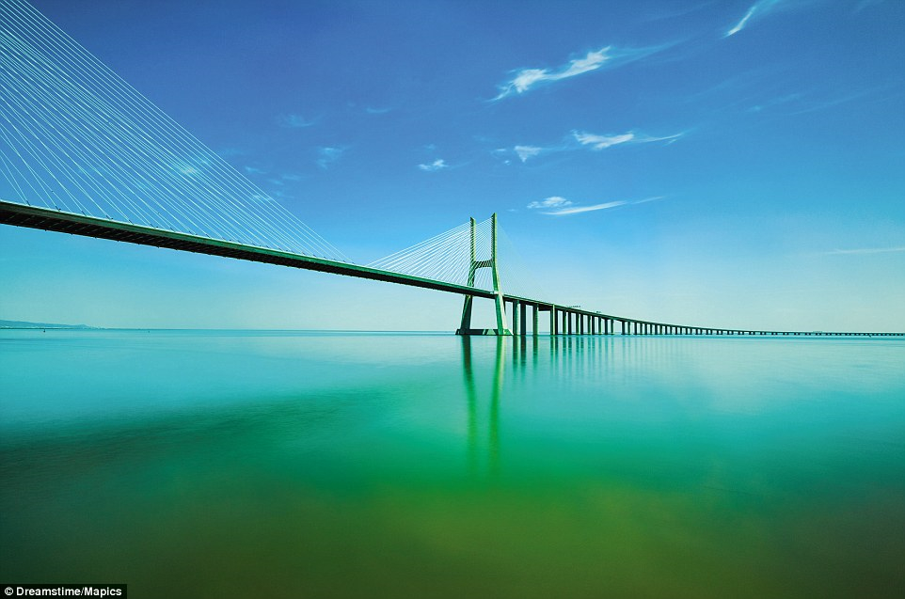The Vasco da Gama Bridge (Portuguese: Ponte Vasco da Gama; pronounced [ˈpõt(ɨ) ˈvaʃku dɐ ˈɡɐmɐ]) is a cable-stayed bridge flanked by viaducts and rangeviews that spans the Tagus River in Parque das Nações in Lisbon, the capital of Portugal. It is the longest bridge in Europe after the Crimean Bridge with a total length of 12.3 kilometres (7.6 mi), including 0.8 kilometres (0.50 mi) for the main bridge and 11.5 kilometres (7.1 mi) in viaducts. The Bridge is served by 4.8 kilometres (3.0 mi) of dedicated access roads. It was built to alleviate the congestion on Lisbon's 25 de Abril Bridge, and eliminate the need for traffic between the country's northern and southern regions to pass through the capital city.

**Contruction**

The $1.1 billion project was split in four parts, each built by a different company, and supervised by an independent consortium. There were up to 3,300 workers simultaneously on the project, which took 18 months of preparation and 18 months of construction. The financing is via a build-operate-transfer system by Lusoponte, a private consortium which receive the first 40 years of tolls of both Lisbon bridges. Lusoponte's capital is 50.4% from Portuguese companies, 24.8% French and 24.8% British. The bridge has a life expectancy of 120 years, having been designed to withstand wind speeds of 250 km/h (155 mph) and hold up to an earthquake 4.5 times stronger than the historical 1755 Lisbon earthquake (estimated at 8.5–9.0 on the moment magnitude scale). The deepest foundation piles, up to 2.2 m (7.2 ft) in diameter, were driven down to 95 m (312 ft) under mean sea level. Environmental pressure throughout the project resulted in the left-bank viaducts being extended inland to preserve the marshes underneath, as well as the lamp posts throughout the bridge being tilted inwards so as not to cast light on the river below.